Pre3Sim1
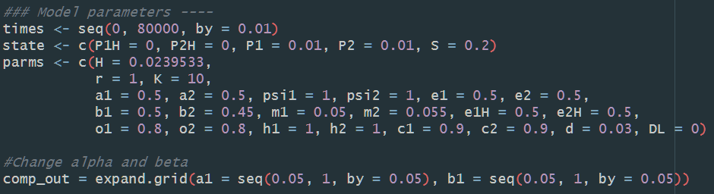
Because now H is small, it is assumed that all the competition outcomes will follow exploitative competition outcomes (as the figure on the left-hand side shows).
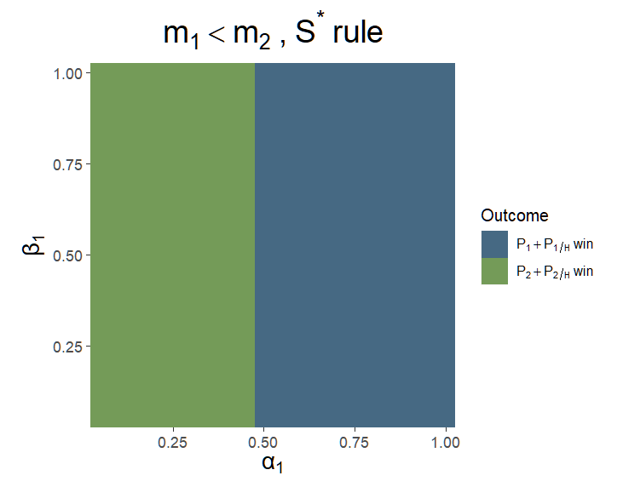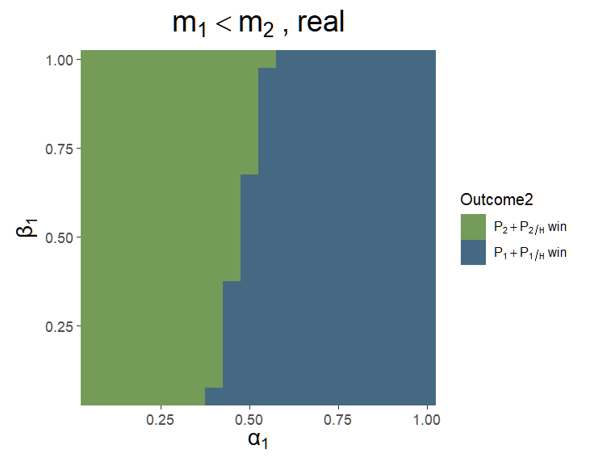
The result shows that in the low H situation (here I set H as a constant with a low value), the competition outcomes do not always follow the exploitative competition outcomes.

Pre1Sim3NC、Pre1Sim2NC2
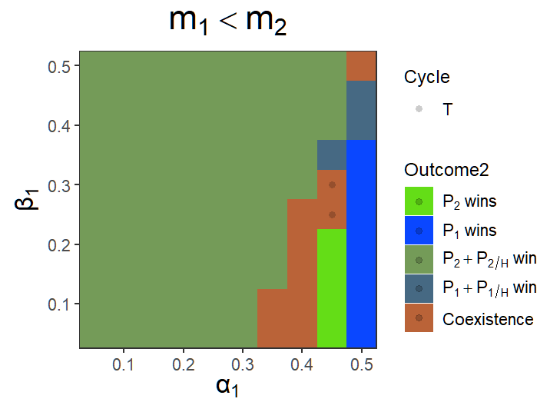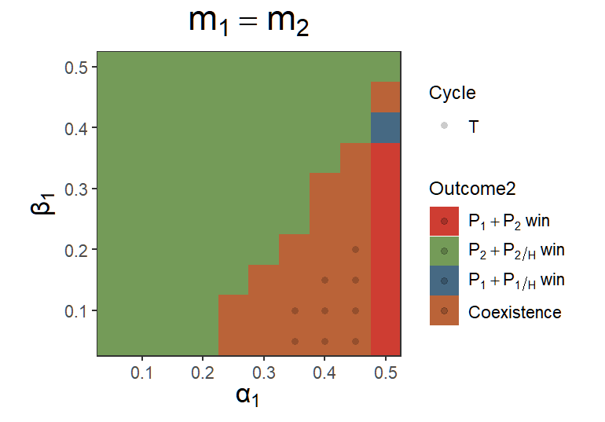
Compared with the system where H is a state variable.

Pre1Sim3NC、Pre1Sim2NC2

When α₁ = 0.35 and β₁ = 0.2; α₂ = 0.5 and β₂ = 0.45:

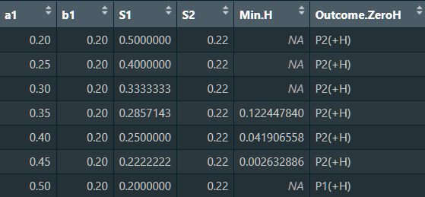
If there is a time separation between H and the other state variable, P₂ will win the competition, and P₁ will be excluded if H is smaller than 0.1244.

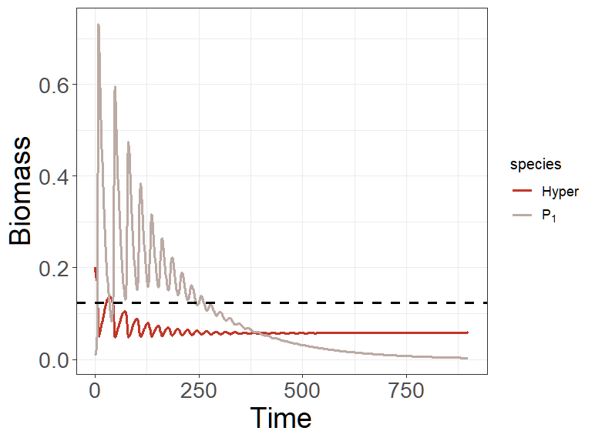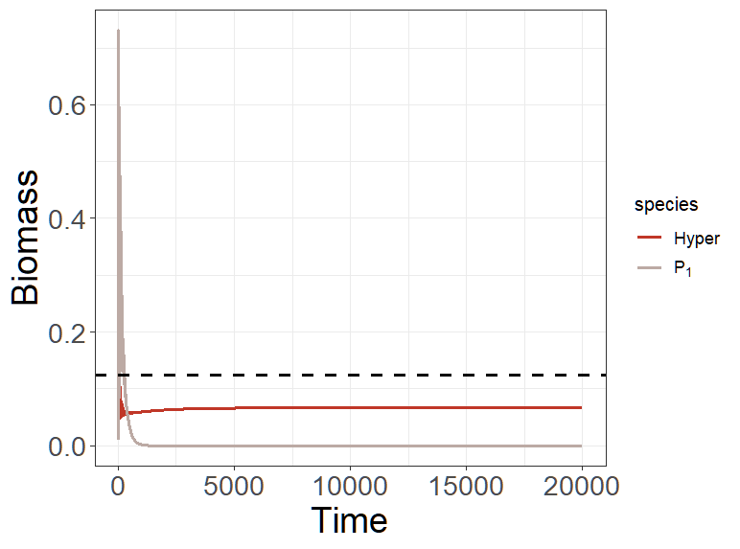
> min(pop_size[,"H"])
[1] 0.02395333
Why will 0.1244 become a threshold when two strains cannot coexist?

When α₁ = 0.4 and β₁ = 0.2; α₂ = 0.5 and β₂ = 0.45:
If there is a time separation between H and the other state variable, P₂ will win the competition, and P₁ will be excluded if H is smaller than 0.0419.

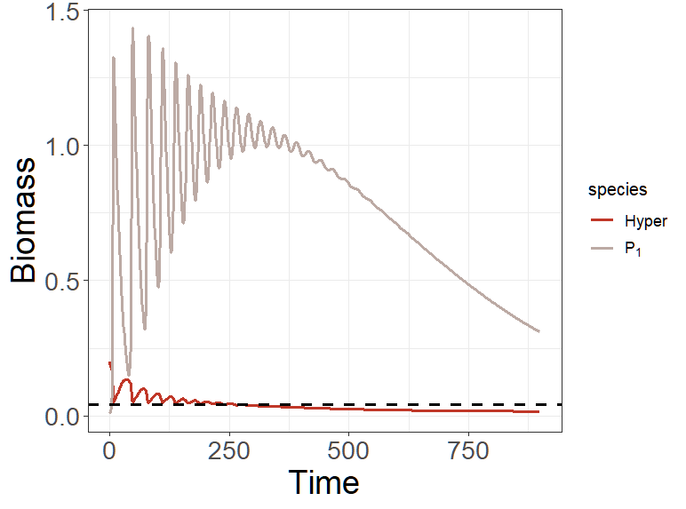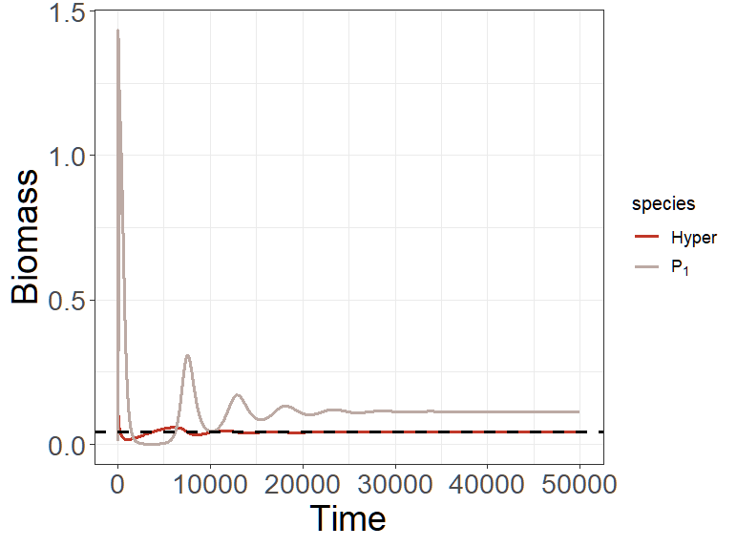
Equilibrium: H = 0.04190443

When α₁ = 0.45 and β₁ = 0.2; α₂ = 0.5 and β₂ = 0.45:
If there is a time separation between H and the other state variable, P₂ will win the competition, and P₁ will be excluded if H is smaller than 0.0026.
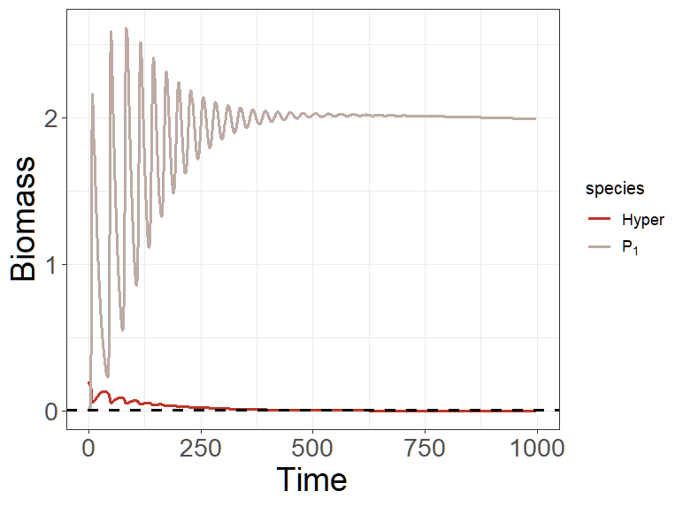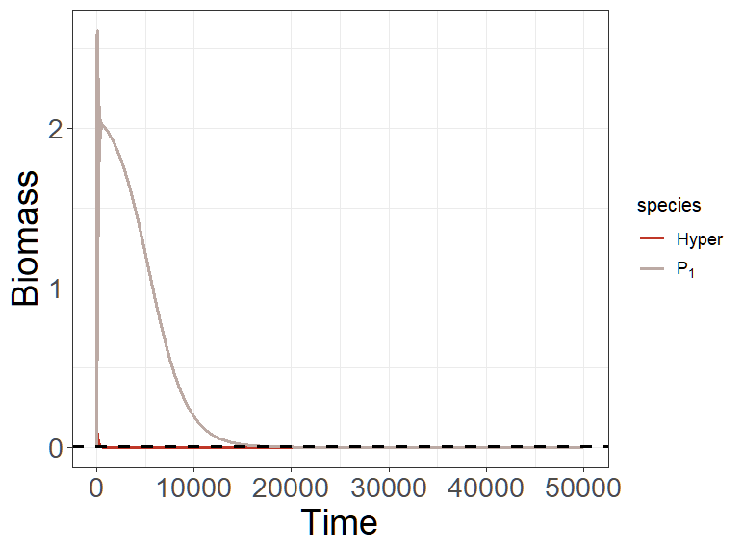
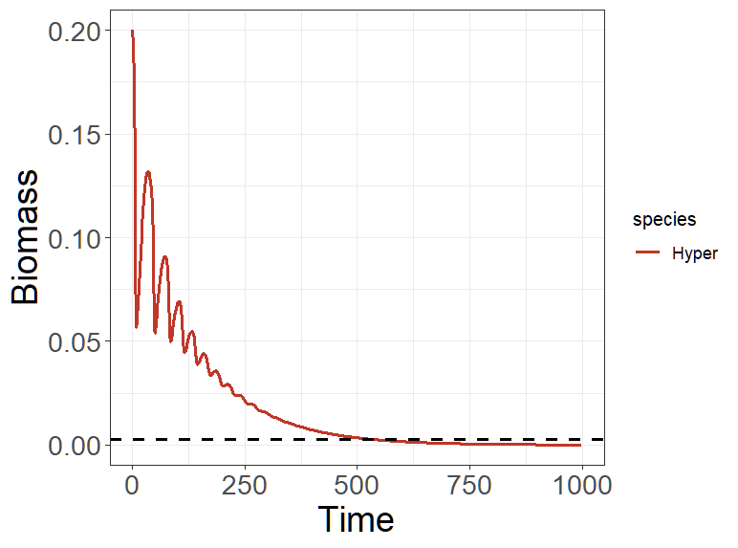
H is extinction here.

